PHASE 6: Documentation & Finalization
1. Objectives
- To prepare complete documentation for the implemented IT ticket classification system.
- To document the system configuration and automation process.
- To provide a clear reference for future maintenance and usage.
- To summarize the results achieved through the project.
- To identify possible future enhancements for the system.
2. Activities Performed
Activity 1: Project Documentation
- Document the project requirements and objectives.
- Document the custom table and field configurations.
- Document Category and Subcategory dependency.
- Document Flow Designer configuration.
- Document testing and validation results.
Activity 2: Final Workflow Documentation
- Document the complete ticket classification workflow.
- Record the keyword-based classification logic:
  - Wi-Fi → Network / Wi-Fi
  - Projector → Hardware / Projector
  - Password → Access / Forgot Password
  - Slow Computer → Performance / Slow Computer.
Activity 3: Final Review
- Review the implemented automation.
- Verify that ticket classification works as expected.
- Verify email notification functionality.
- Review data accuracy and system configuration.
Activity 4: Future Enhancement Documentation
Document possible future enhancements such as:
- Assignment automation.
- SLA tracking.
- Predictive intelligence.
- Additional automation features.
3. Expected / Produced Output
- Complete project documentation.
- Documented system configuration and workflow.
- Documented testing results.
- Final project report.
- Future enhancement list.
- A maintainable and scalable IT ticket classification solution.

4. Data Flow Diagram
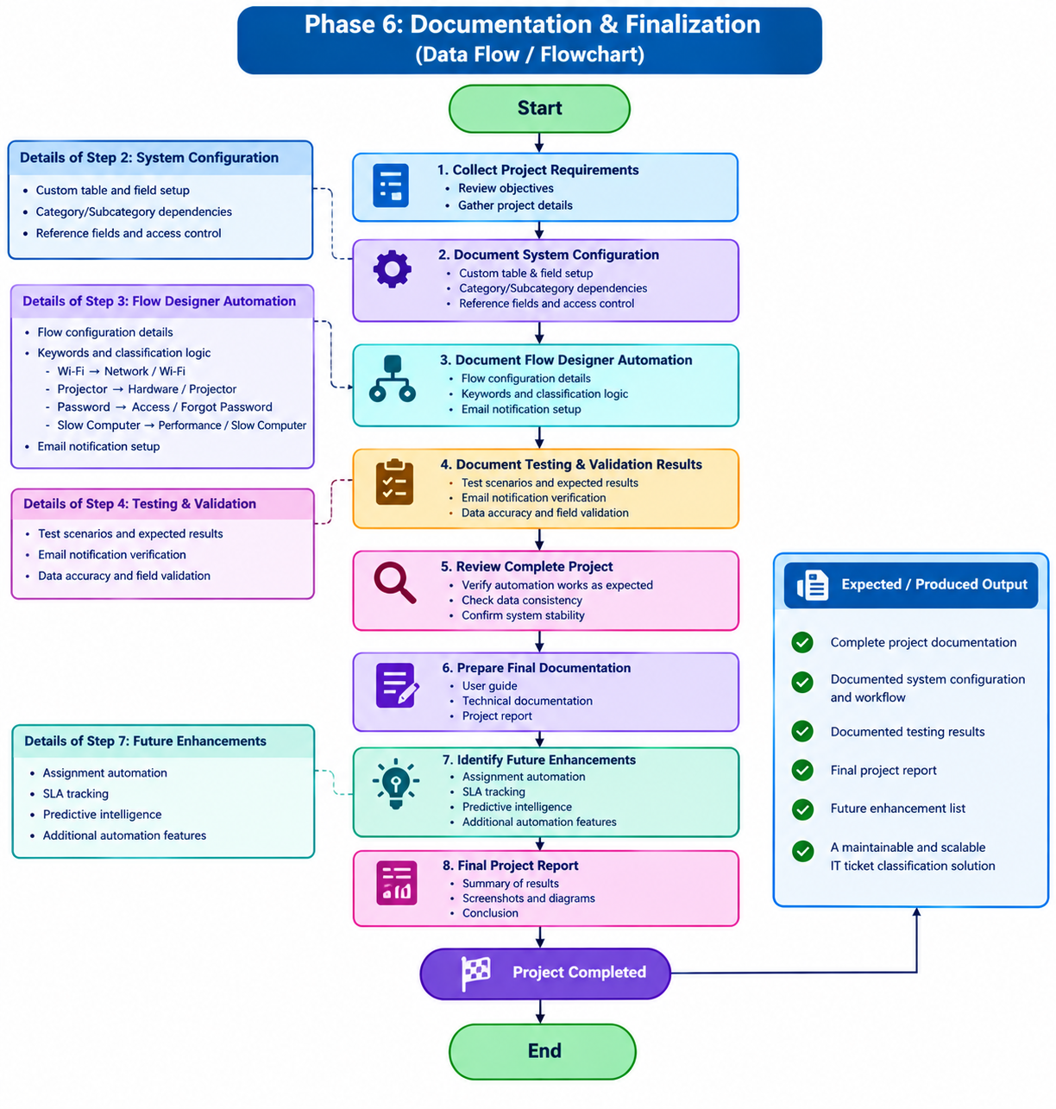

Data Flow:
Project Information → System Documentation → Workflow Documentation → Testing Results → Final Review → Final Report → Project Completion.

